Ejercicio 1

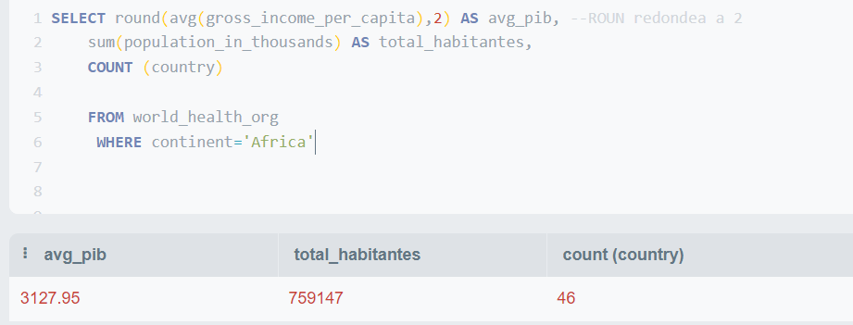

CONOCER LOS MISMOS DATOS POR CONTINENTE

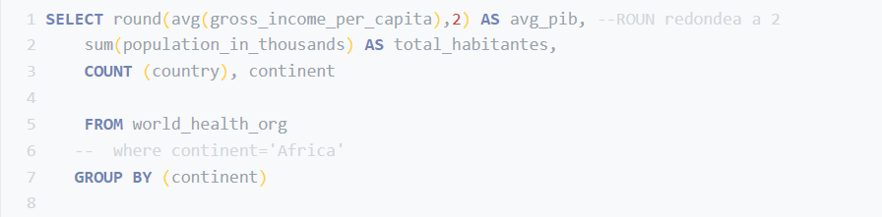

EJERCICIO 2

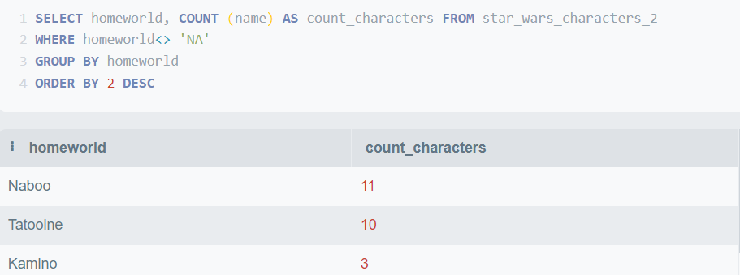

SELECT homeworld, count (name) as count_characters FROM star_wars_characters_2

where homeworld<> 'NA'

group by homeworld -- TAMBIÉN PODRÍA PONER 1

--HAVING homeworld <> 'NA'esta sería otra opción

order by 2 DESC

ejercicio 3

select bond_actor_salary,actor, ROUND(SUM(bond_actor_salary),2)

from jamesbond

group by actor

HAVING SUM(bond_actor_salary)>0

ORDER BY 3 DESC - - SOLO SE PUEDEN PONER NÚMEROS EN ORDER BY Y GROUP BY

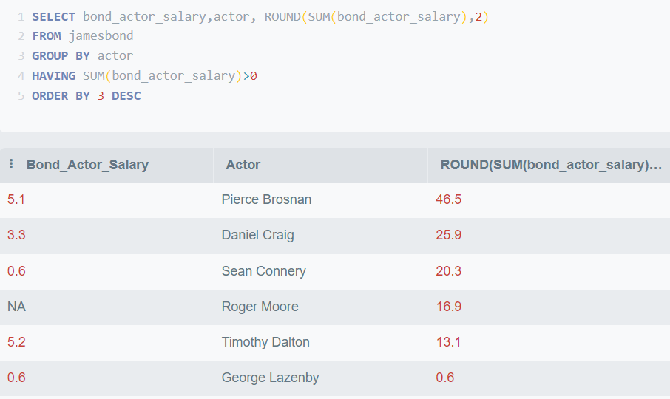

EJERCICIO 5

Calcular la facturación (box office) según director. Filtrar por aquellos directores que hayan generado más de 1500 en el total de la facturación (todas las películas).

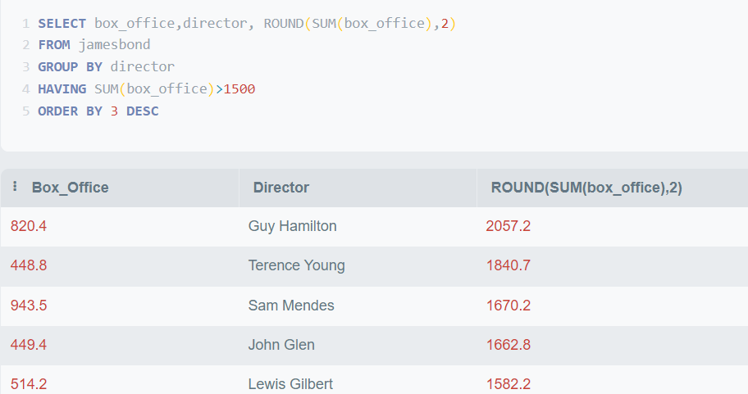

select box_office,director, ROUND(SUM(box_office),1) as total_box_office

from jamesbond

group by director

HAVING SUM(box_office)>1500

ORDER BY ROUND(SUM(box_office),1) DESC

6.- Calculator número total de álbumes según sub metal genre, filtrar por aquellos sugéneros con al menos 10 álbumes

select sub_metal_genre, COUNT(album)

from rolling_top_albums_1

group by sub_metal_genre

HAVING COUNT(album)>=10

ORDER BY COUNT(album) DESC

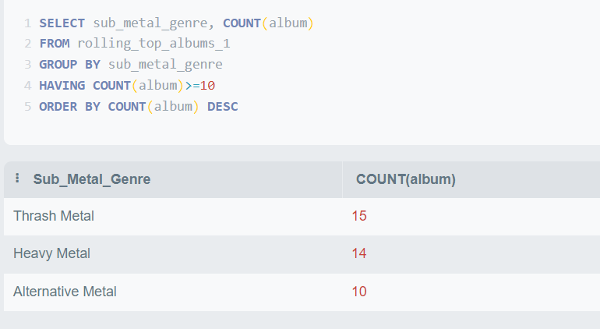

ej 4

select

CASE WHEN gender LIKE '%Action%' THEN 'Action_movies' else 'resto' end as genERO,

COUNT(movie_title), AVG (imdb_score)

from imdb_movies

GROUP BY genERO

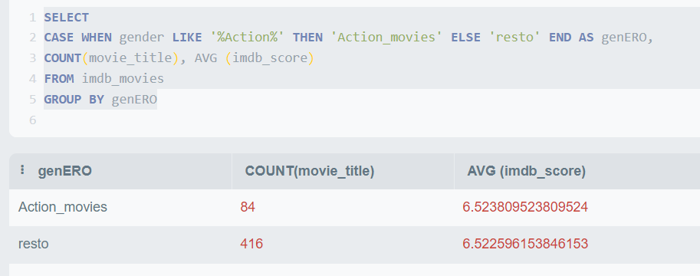

select

CASE WHEN gender LIKE '%Action%' THEN 'Action_movies' else 'resto' end as genERO,

COUNT(movie_title),ROUND( AVG (imdb_score),2)

from imdb_movies

GROUP BY genERO

EJ 7

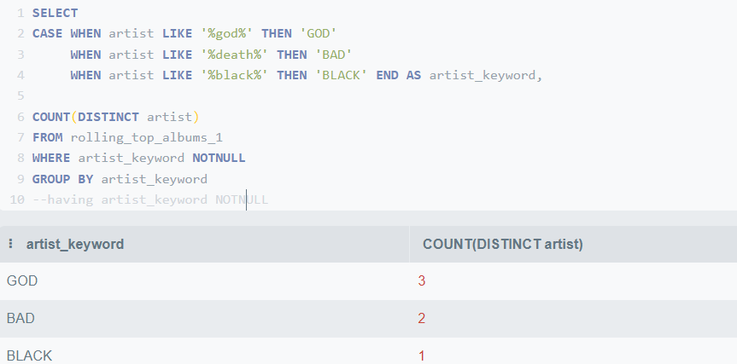

select

CASE WHEN artist LIKE '%god%' THEN 'GOD'

when artist LIKE '%death%' THEN 'BAD'

when artist LIKE '%black%' THEN 'BLACK' end as artist_keyword,

COUNT(DISTINCT artist)

from rolling_top_albums_1

WHERE artist_keyword NOTNULL

GROUP BY artist_keyword

--having artist_keyword NOTNULL

ORDER BY 2 DESC

ej 8

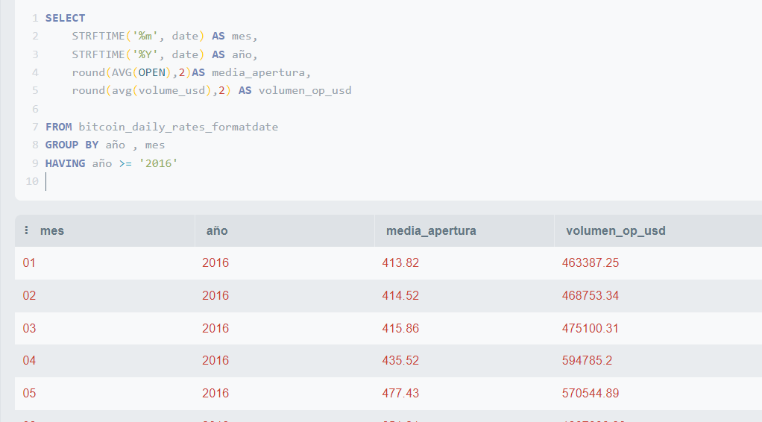

SELECT

STRFTIME('%m', date) as mes,

STRFTIME('%Y', date) as año,

round(AVG(open),2)as media_apertura,

round(avg(volume_usd),2) as volumen_op_usd

FROM bitcoin_daily_rates_formatdate

group by año , mes

HAVING año >= '2016'

--order by mes

ej 9

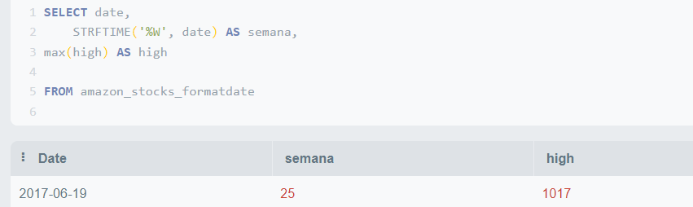

SELECT date,

STRFTIME('%W', date) as semana,

max(high) as high

FROM amazon_stocks_formatdate

ej 10

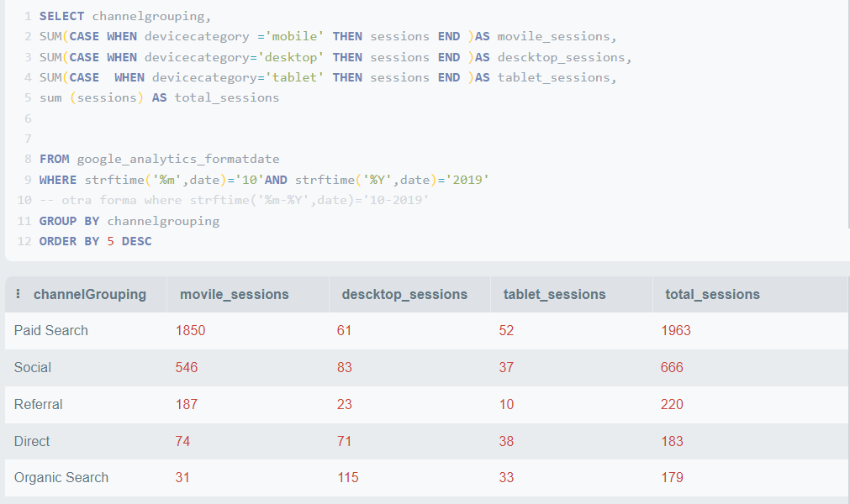

SELECT channelgrouping,

SUM(CASE WHEN devicecategory ='mobile' then sessions end )as movile_sessions,

SUM(CASE when devicecategory='desktop' then sessions END )AS descktop_sessions,

SUM(CASE when devicecategory='tablet' then sessions end )as tablet_sessions,

sum (sessions) as total_sessions

FROM google_analytics_formatdate

where strftime('%m',date)='10'and strftime('%Y',date)='2019'

GROUP BY channelgrouping

order by 5 DESC